Mercy Club Meet-Ups at
Almost Home Restaurant

Directions to Almost Home
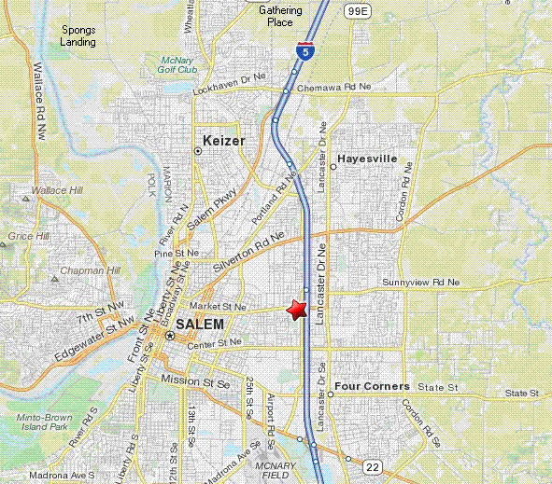
Directions from Keizer (The Gathering Place, this example);

1: Start by turning LEFT out of the Gathering Place and go NORTHEAST on OR-219 toward QUINABY RD NE.

2: After 1.4 mi, Turn RIGHT onto BROOKLAKE RD NE.

3: After 0.7 mi, Merge onto I-5 S toward SALEM.
4: After 6.9 mi, Take the OR-213/MARKET ST. exit, EXIT 256, toward LANCASTER MALL.
5: After 0.3 mi, Take the ramp toward CITY CENTER.
6: After 0.1 mi, Turn SLIGHT RIGHT onto MARKET ST NE.

7: After 0.1 mi, 3310 MARKET ST NE is on the LEFT.

MERCY – the Medical Cannabis resource Center - has organized a Mercy Club meet-up every Wednesday, 7pm - 9pm, (excepting Holidays) the Almost Home restaurant in Salem. Located at 3310 Market St NE, Salem, OR, 97301. And HEY! The owner is allowing an enclosed tent to be set up in/on the Smokers Patio outside and Clone Exchanges and the like in a Private Room. NOTE: PLEASE bring the Clones and other Medical Cannabis Resources into and thru the Restaurant in non-transparent containers so they will NOT be in "public view". People failing to do so will NOT be in compliance with OMMA and are assuming their own responsibility, as well as messing with the bizness, and that's a heck of a reward for allowing all this. For more info about The Mercy Club, or Meetings and Meet-Ups in general, call MERCY at: 503.363-4588 –or- visit:
www.MercyCenters.org

